In Memoriam: Iris Bouwman
(21 June 1952 – 21 August 2025)

This summary provides an overview of Iris's life story, calling, prophetic visions, missionary work, teaching, and legacy, focusing on her role in the restoration of the Israel family and end-time preparation as she experienced and passed it on.
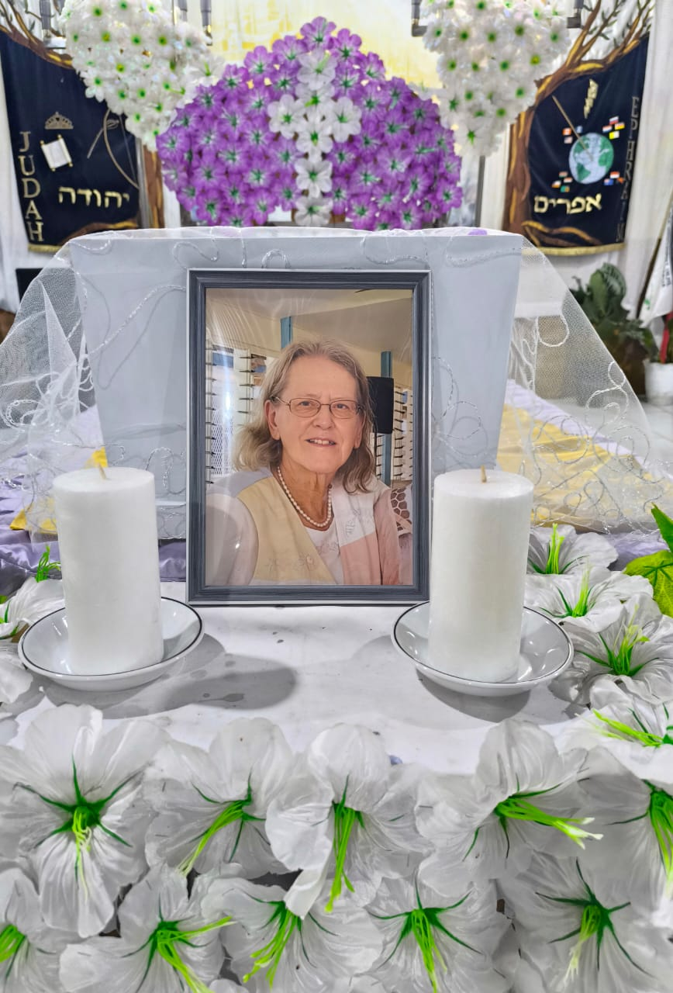This document is a very abbreviated account of the prophetic life story and calling of Iris Bouwman, from her childhood to her work and ministry in different parts of the world, with a strong focus on the relationship between Israel, Judah and Ephraim, and the end times written by Bob van Dijk.
This story is deeply intertwined with Bible prophecy, missionary work, spiritual revelations, and travels to Israel, Papua, Australia, and the South Pacific. The document also outlines her role in preparing for the restoration of God's Kingdom on earth and her involvement in various revivals and spiritual movements.
The beginning of the vocation and missionary work
Iris was born in 1951 in The Hague and felt called at an early age, inspired by missionary stories such as those of John Paton. Her calling was given a prophetic basis through Matthew 24:14, in which she heard that Israel will play a major role at the end of time. After training as a nurse, she wanted to travel to Israel, but the Yom Kippur War made this impossible. Later she worked in Israel and Africa and met Janny Holster, with whom she entered into a lifelong collaboration within the faith mission RBMU, known for Don Richardson's book Peace Child. She was educated in Scotland and learned about the "seed principle" of God, which deepened her understanding of God's plan for Israel and the nations.
The deployment to Papua and the first missionary phase (1983-2003)
In 1983 Iris, together with Janny, left for Papua (formerly Irian Jaya) under the Irian Jaya Mission Foundation. They learned Indonesian and regularly had to deal with visa problems. They had a special relationship with the Papuans and were involved in a revival in Papua in 1995, which opened the door to a greater understanding of God's plan for Israel and the nations. During this period, they also encountered visions and prophecies that prepared them for their role in the end times, including the Toronto Blessing and the "Father's Blessing."
Sabbath, Moadim and prophetic visions
Iris and Janny focused their lives around the Moadiem, God's feast days, and saw them as preparations for the fulfillment of God's plan. During a revival, Iris saw four angels stretching a prayer rug (tallit) over the earth with Jerusalem in the middle, symbolizing universal connectedness. These visions emphasized the connection between the nations and Israel and the need for spiritual preparation.
The second phase of the vocation and the restoration of the family (2003-2023)
From 2003 onwards, the Irian Jaya Mission Foundation changed into Judah and Ephraim Ministries, emphasizing building a bridge between the nations and Israel, and returning to Jerusalem as the origin of the gospel. Iris lived alternately in Israel and Papua, building relationships with local leaders and being involved in national Sabbath celebrations for Papuans. The Papuans brought gold to the Temple Institute in Jerusalem in fulfillment of Bible prophecies, which was a sign of solidarity and blessing. Australia also received a special calling as a "king's land" in God's Kingdom, with prophetic journeys and sealings of the continent with "blood markers" and the celebration of the Lord's Supper.
Journeys to the Four Corners of the Earth and Prophetic Messages
Iris made prophetic journeys to Canada, New Zealand, Chile, Russia, and other places, receiving messages about the darkness that will cover the earth, the gathering of God's sheep, the preparation for the Sabbath, and the impending battle around Israel. These trips confirmed the role of Israel and the nations in the end-time plan and emphasized the need for spiritual vigilance and unity between Judah and Ephraim.
The Meeting in the Desert and Preparing for Recovery
An important theme in the story is the encounter with God in the desert, a place of preparation and cleansing, prior to the establishment of God's Kingdom on earth. Iris and Janny lived near Tamar, opposite Bozra (Edom), a symbolic place for the coming redemption and judgment. Here, too, the symbolism of the pomegranate tree (with 613 seeds, referring to the Torah) became important as a sign of hope and restoration. The desert is seen as the place where God will meet His people before He sets His feet on the Mount of Olives in Jerusalem.
Study days, education and the role of Ephraim
Iris gave study days and organized trips to teach God's plan for Judah and Ephraim. She emphasized the importance of recognizing Ephraim as believers from the nations and the need for unity with Judah. She spoke about the birth pangs of Ephraim, the mystery of Israel, and the calling to work together as a "minyan" (priestly congregation) in the restoration of God's Kingdom. These teaching activities were designed to reduce confusion and clarify the role of the tribes and the family in God's plan.
The Ten Awesome Days and the "Dress Rehearsal"
A special trip was organized around the Jewish holidays, during which people symbolically experienced the ten awe-inspiring days in Israel. These days were meant to prepare for the coming Sabbath and the restoration of the family. During this trip they reflected on texts from the Bible about the encounter in the desert, the role of the Messiah, the suffering of Yeshua, and the importance of testimony and humility. The trip ended with a festive conclusion in Jerusalem, where the participants prepared for the coming Kingdom.
Departure from Europe and new assignments
In 2018, Iris and Janny symbolically left the Netherlands and Europe, making a trip to Berlin with the "altar of Pergamum" and to Rome and its Vatican to break free from European influences. This was an important step in her calling to be free for her work in Australia and Papua. This was followed by a farewell service in Dordrecht and a transition to a new mandate area. In Australia and Papua, they continue their ministry despite personal challenges, including the death of her partner Janny in 2021
Current phase and future vision
From 2022 onwards, a new phase began in which Iris focused on closely involved leaders and strengthening four 'mobile ministries' within the board of Judah and Ephraim Ministries. She taught about the role of mothers in Israel, the struggles they are in, and the need for conversion and renewal. She emphasized the role of women in recovery and redemption. She was also involved in the Pacific Council, which focuses on Papua New Beginning and the unification of Papua and Papua New Guinea. Her mission extends from Papua to the Pacific Islands, with a focus on the "One New Man" and the fulfillment of God's Master Plan.
Death and Legacy
On August 21, 2025, Iris passed away suddenly, but her mission and ministry will be continued by other leaders. A major conference is planned in Vanimo in early October to reunite Papua and PNG under the new covenant with God, as she had prepared it. Her legacy consists of teaching, prophetic journeys and connecting nations with Israel in the context of God's Kingdom.
May her memory inspire us to continue running the race ahead (Hebrews 12:1-2).

